PARTNER VISA-STANDARD OPERATING PROCEDURE

Document Control
Document No. | SOP-PV-001
Version | 1.0
Department | Migration Services
Effective Date | ________________
Approved By | ________________

Purpose
This Standard Operating Procedure (SOP) establishes a consistent, efficient and compliant process for managing Partner Visa (Subclass 820/801) applications from the initial client enquiry through to the final visa outcome.
This SOP aims to:
- Standardise the Partner Visa application process across the organisation.
- Ensure compliance with Australian migration legislation and Department of Home Affairs requirements.
- Clearly define the responsibilities of Registered Migration Agents and Consultants.
- Deliver professional, efficient and client-focused migration services to applicants and sponsors.
- Maintain accuracy, consistency and quality throughout the sponsorship and visa application process.
- Ensure all client records and supporting documents are securely managed in accordance with Yale Migration's Document Management Procedure.
- Minimise application errors, processing delays and compliance risks through effective quality assurance.
- Promote continuous improvement and operational excellence.

- Scope
This procedure applies to all Partner Visa (Subclass 820/801) applications managed by Yale Migration.
The SOP covers:
- Initial client enquiry
- Applicant eligibility assessment
- Sponsor eligibility assessment
- Client engagement
- Relationship assessment
- Document collection and verification
- Preparation of relationship evidence
- Sponsorship application
- Visa application preparation
- Internal quality review
- Visa lodgment
- Post-lodgment monitoring
- Health and character requirements
- Requests for Further Information (Section 56)
- Temporary Partner Visa (Subclass 820) outcome
- Permanent Partner Visa (Subclass 801) follow-up and document preparation
- Final visa outcome management

Roles and Responsibilities

Registered Migration Agent
The Registered Migration Agent is responsible for providing migration advice and ensuring compliance throughout the Partner Visa application process.

Responsibilities
- Assess the eligibility of both the applicant and sponsor.
- Identify migration risks and provide professional advice.
- Conduct consultations with both the applicant and sponsor.
- Assess whether the relationship satisfies the legislative requirements for a genuine and continuing relationship.
- Prepare quotations.
- Prepare Service Agreements.
- Review sponsorship eligibility.
- Review all supporting relationship evidence.
- Review Forms 47SP, 40SP and Form 888 declarations (where applicable).
- Review health and character requirements.
- Conduct final quality assurance before lodgment.
- Lodge the Partner Visa application through ImmiAccount.
- Monitor application progress.
- Respond to Department requests, including Section 56 Requests.
- Provide advice regarding the Subclass 820 grant and subsequent Subclass 801 process.
- Provide post-decision migration advice where required.

Consultant
The Consultant is responsible for coordinating communication, documentation and administrative support throughout the application process.

Responsibilities
- Respond to applicant and sponsor enquiries.
- Conduct the initial client screening.
- Collect preliminary information.
- Endorse eligible enquiries to the Registered Migration Agent.
- Send applicant and sponsor document checklists.
- Register clients in the Client Management System.
- Generate Unique Client Codes.
- Create electronic client folders.
- Coordinate document collection.
- Review documents for completeness.
- Assist in preparing relationship evidence.
- Prepare supporting documentation for the sponsorship and visa application.
- Follow up outstanding documents.
- Prepare invoices.
- Monitor application progress.
- Provide regular updates to applicants and sponsors.
- Upload documents into ImmiAccount following approval by the Registered Migration Agent.
- Update internal tracking systems.
- Maintain complete and accurate client records.

4. Tools and Systems
The following systems and resources are used throughout the Partner Visa (Subclass 820/801) application process.

Systems
- ImmiAccount
- Client Management System (CMS)
- Client Engagement Log
- Secure Cloud Document Storage
- Microsoft Office / Google Workspace
- Email Management System

Standard Templates and Checklists
- Partner Visa (Subclass 820/801) Checklist
- Applicant Checklist
- Sponsor Checklist
- Relationship Evidence Checklist
- Relationship Statement Template (Applicant)
- Relationship Statement Template (Sponsor)
- Form 888 Checklist
- Sponsorship Checklist
- Visa Application Checklist
- Health and Character Checklist
- Client Information Sheet
- Service Agreement
- Client Quotation Template
- Client Consent Form

Reference Materials
- Department of Home Affairs Legislative Instruments
- Department of Home Affairs Policy Manual
- Temporary Activities Sponsorship (TAS) Guidelines
- Occupational Training Program Guidelines
- ANZSCO Occupation List
- Department of Home Affairs Forms and Approved Templates
- Yale Migration Document Management Procedure
- Internal Quality Assurance Checklist
- Internal Training Visa Reference Guide
- Immiccount
- Client Management System
- Client Engagement Log
- Secure Cloud Document Storage
- Employer Checklist
- Employee Checklist
- Standard Business Sponsorship Checklist
- Labor Market Testing Checklist
- Nomination Checklist
- Visa Application Checklist
- Microsoft Office / Google Workspace
- Department of Home Affairs Legislative Instruments
- Skills in Demand Occupation List Reference
- CSIT Salary Reference Guide

5. Document Management

Every client must be registered in the Client Engagement Log to generate a Unique Client Code

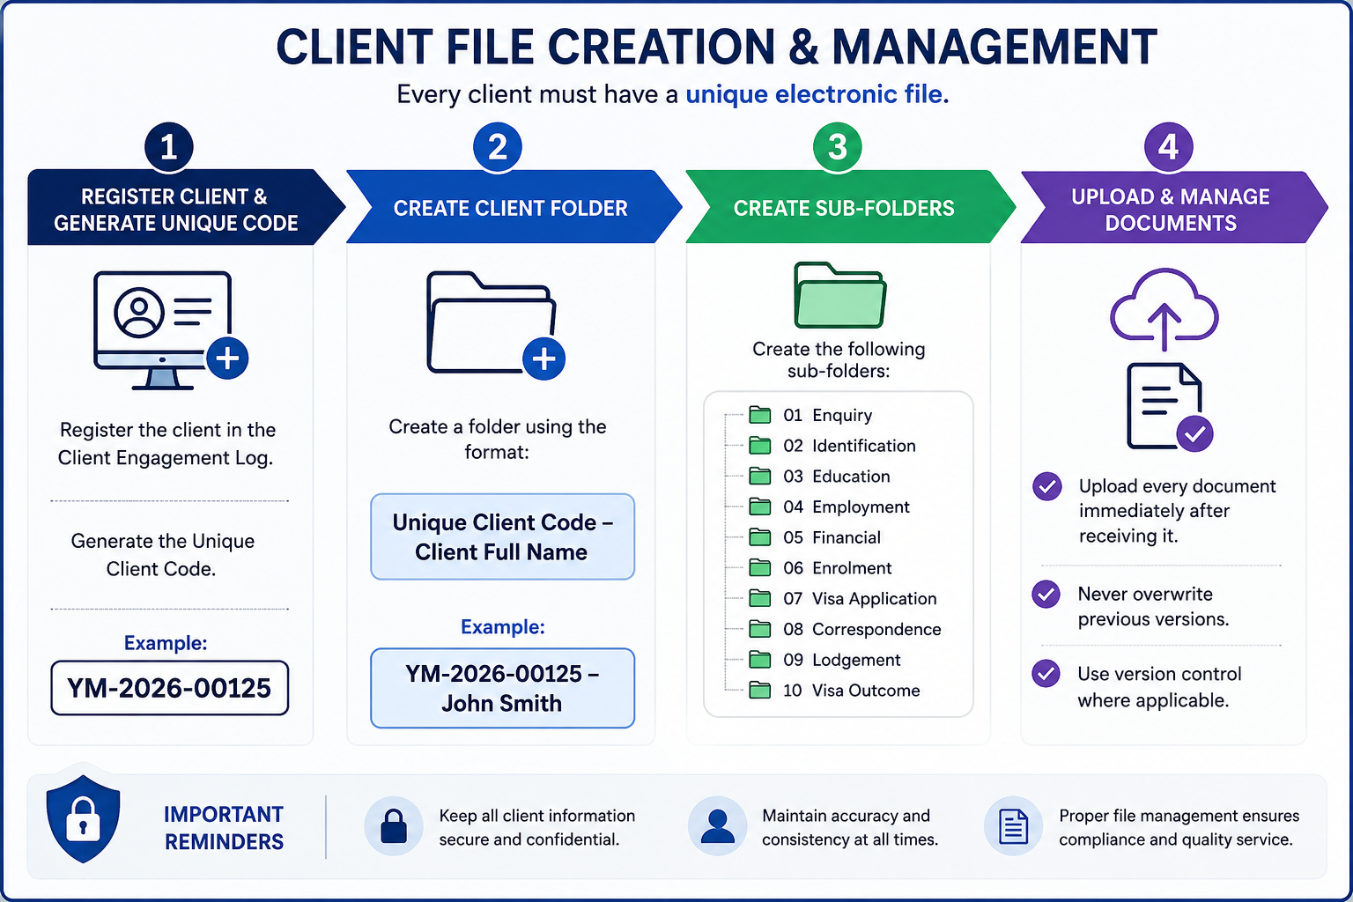

Step | Process | Procedure
1 | Register Client | Register the client in the Client Engagement Log and generate a Unique Client Code.  Example: YM-2026-00125
2 | Create Client Folder | Create a client folder using the following naming convention:  Unique Client Code – Client Full Name  Example: YM-2026-00125 – John Smith
3 | Create Sub-Folders | Create the following folders within the client's main folder:  01. Enquiry  02. Identification  03. Education  04. Employment  05. Financial  06. Enrolment  07. Visa Application  08. Correspondence  09. Lodgment  10. Visa Outcome
4 | Upload & Maintain Documents | Upload all client documents immediately upon receipt.  • Do not overwrite previous versions.  • Apply version control where necessary.  • Ensure all documents are saved in the correct sub-folder.

6. Partner Visa (Subclass 820/801) Application Procedure

Step | Process | Responsible | Required Action
1 | Receive Enquiry | Consultant | Respond to enquiries from the applicant or sponsor via phone, email, social media or walk-in. Obtain preliminary information regarding the relationship, visa status and eligibility.
2 | Initial Assessment | Consultant | Request the completed enquiry form, applicant and sponsor details, passports, current visa (if applicable), relationship timeline and supporting documents.
3 | Eligibility Assessment | Registered Migration Agent | Assess the eligibility of both the applicant and sponsor. Confirm the relationship meets the legislative requirements for a spouse or de facto relationship and identify any migration risks. (Immigration and citizenship Website)
4 | Client Consultation | Registered Migration Agent | Conduct a detailed consultation explaining visa requirements, sponsorship obligations, relationship evidence, health and character requirements, processing stages, government fees, professional fees and expected processing times.
5 | Client Engagement | Consultant | Register the applicant and sponsor in the Client Engagement Log, generate Unique Client Codes, create electronic client folders, and send the quotation, Service Agreement and Partner Visa document checklist.
6 | Service Agreement & Initial Payment | Consultant | Obtain the signed Service Agreement and confirm receipt of the engagement fee before commencing the application.
7 | Document Collection | Consultant | Collect all required applicant and sponsor documents, including identity documents, relationship evidence, police clearances, financial documents and supporting declarations.
8 | Document Verification & Storage | Consultant | Review all documents for completeness and consistency. Upload documents into the client's electronic folder following the Document Management Procedure.
9 | Relationship Evidence Assessment | Registered Migration Agent | Assess all evidence against the four relationship aspects: financial aspects, nature of the household, social aspects, and commitment to each other. Identify any gaps requiring additional evidence. (Immigration and citizenship Website)
10 | Relationship Statements & Form 888 | Consultant | Assist the applicant and sponsor in preparing their relationship statements. Collect completed Form 888 declarations and identification documents from eligible witnesses, where applicable.
11 | Sponsorship Application Preparation | Registered Migration Agent | Prepare the sponsorship application, ensuring the sponsor meets all eligibility and sponsorship requirements.
12 | Visa Application Preparation | Consultant | Prepare the Partner Visa (Subclass 820/801) application, upload supporting documents and complete the ImmiAccount draft.
13 | Client Review & Approval | Consultant | Send the completed application draft to both the applicant and sponsor for review. Obtain written confirmation that all information is true, complete and accurate before lodgment.
14 | Final Review & Visa Lodgement | Registered Migration Agent | Conduct the final quality assurance review and lodge the Partner Visa (Subclass 820/801) application through ImmiAccount. Both the temporary (820) and permanent (801) stages are applied for together, with one application charge payable at lodgment. (Immigration and citizenship Website)
15 | Update Internal Records | Consultant | Update the Lodgment Register with the Transaction Reference Number (TRN), lodgment date, Bridging Visa details (if applicable) and expected follow-up dates.
16 | Post-Lodgment Communication | Consultant | Send the applicant the visa lodgment acknowledgement, Bridging Visa Grant (if applicable), HAP ID, health examination instructions and any additional post-lodgment information.
17 | Application Monitoring | Consultant / Registered Migration Agent | Monitor the application through ImmiAccount. Respond promptly to Requests for Further Information (Section 56), monitor health and character requirements, and keep both the applicant and sponsor informed throughout processing.
18 | Temporary Visa Outcome (Subclass 820) | Registered Migration Agent / Consultant | Notify the applicant and sponsor of the Subclass 820 visa outcome. Explain visa conditions, work rights, Medicare eligibility (if applicable) and the future Subclass 801 process.
19 | Subclass 801 Follow-up | Consultant | Approximately two years after the initial Partner Visa application lodgment, contact the client to request updated relationship evidence and prepare the permanent Partner Visa (Subclass 801) assessment documents. (Immigration and citizenship Website)
20 | Permanent Visa Outcome (Subclass 801) | Registered Migration Agent / Consultant | Notify the applicant of the Subclass 801 visa outcome. Explain permanent residency rights, entitlements and any future eligibility for Australian citizenship (where applicable).
21 | File Closure | Consultant | Save all final correspondence, update the Client Engagement Log and Lodgment Register, and archive the applicant and sponsor files in accordance with the Document Management Procedure.

Internal Quality Control Points
Before lodging the Partner Visa application, ensure the following:
- Applicant eligibility confirmed.
- Sponsor eligibility confirmed.
- Relationship assessed as genuine and continuing.
- Relationship evidence addresses the four legislative aspects:
  - Financial aspects of the relationship
  - Nature of the household
  - Social aspects of the relationship
  - Nature of the couple's commitment to each other
- Relationship statements completed by both the applicant and sponsor.
- Form 888 declarations and supporting identification documents collected (where applicable).
- Police clearance certificates obtained or applied for.
- Health examination requirements explained to the applicant.
- Sponsorship application reviewed for completeness and compliance.
- Visa application reviewed and approved by the Registered Migration Agent.
- Applicant and sponsor have reviewed and approved the final application before lodgment.
- Government Visa Application Charges (VAC) and professional fees confirmed.
- All supporting documents have been correctly named, organized and uploaded to ImmiAccount.
- Internal records, Client Engagement Log and Lodgment Register updated.
- Follow-up reminder scheduled for the Subclass 801 evidence request approximately two years after the initial Partner Visa lodgment.
- Final quality assurance completed by the Registered Migration Agent prior to lodgment.

7. Quality Control Checklist
The Registered Migration Agent must complete the following quality assurance checks before lodging any Partner Visa (Subclass 820/801) application. No application is to be lodged until all applicable items have been reviewed and confirmed.
Quality Check | Completed (✓)
Applicant identity has been verified using a valid passport or government-issued identification. | ☐
Sponsor identity and Australian citizenship, permanent residency or eligible New Zealand citizenship have been verified. | ☐
Applicant meets the eligibility requirements for the Partner Visa (Subclass 820/801). | ☐
Sponsor meets the sponsorship eligibility requirements under Australian migration legislation. | ☐
The relationship has been assessed as genuine and continuing. | ☐
Relationship evidence adequately addresses the four legislative aspects: financial aspects, nature of the household, social aspects, and commitment to each other. | ☐
Relationship statements from both the applicant and sponsor have been reviewed and approved. | ☐
Form 888 declarations and supporting identification documents have been obtained (where applicable). | ☐
Applicant's police clearance certificates have been obtained or applied for. | ☐
Sponsor's police clearance has been obtained where required. | ☐
Health examination requirements have been explained and HAP ID issued where applicable. | ☐
All supporting documents have been reviewed for completeness, accuracy and consistency. | ☐
Applicant and sponsor information is consistent across all forms, declarations and supporting documents. | ☐
All required forms, declarations and consent documents have been completed and signed. | ☐
Sponsorship application has been reviewed for completeness and compliance. | ☐
Applicant and sponsor have reviewed and approved the final visa application before lodgement. | ☐
Government Visa Application Charges (VAC), professional fees and all applicable third-party costs have been confirmed with the client. | ☐
All supporting documents have been correctly named, organised and saved in accordance with the Document Management Procedure. | ☐
Registered Migration Agent has completed the final compliance review and approved the application for lodgement. | ☐
Partner Visa (Subclass 820/801) application has been successfully lodged through ImmiAccount. | ☐
Transaction Reference Number (TRN), lodgement confirmation and all post-lodgement records have been saved in the client file. | ☐
Reminder has been scheduled for the Subclass 801 permanent visa stage and follow-up relationship evidence approximately two years after the initial lodgement. | ☐

Important
- Any missing, inconsistent or incomplete information must be resolved before the application is lodged.
- Relationship evidence must demonstrate that the relationship is genuine and continuing and satisfy the four legislative assessment aspects.
- All supporting documents must be clear, complete and, where required, certified or accompanied by an accredited English translation.
- Any Request for Further Information (Section 56) issued by the Department of Home Affairs must be responded to before the specified deadline.
- The Registered Migration Agent is responsible for ensuring that the sponsorship and visa application comply with current Australian migration legislation, Department of Home Affairs policy and professional obligations before lodgement.
- A follow-up review must be scheduled to prepare and collect updated relationship evidence for the Subclass 801 permanent visa assessment when the applicant becomes eligible.

8. Compliance and Disclosure
Yale Migration is committed to maintaining the highest standards of professionalism, ethical conduct and compliance with Australian migration legislation.
All staff involved in Graduate Visa applications must comply with the following requirements:

Legislative Compliance
- Comply with all applicable Australian migration legislation, regulations and policy requirements.
- Follow all requirements of the Department of Home Affairs when preparing and lodging visa applications.
- Ensure that all information provided in a visa application is accurate, truthful and supported by appropriate evidence.

Professional Responsibilities
- Only a Registered Migration Agent may provide migration advice or make legal representations regarding visa matters.
- Consultants and administrative staff must not provide migration advice unless authorised to do so.
- Any complex migration issues must be referred to the Registered Migration Agent.

Client Confidentiality
- Protect all client information in accordance with Australian privacy requirements and the agency's privacy policy.
- Client information must only be accessed by authorized staff for legitimate business purposes.
- Client documents must be stored securely within the agency's approved document management system.

Accuracy and Record Management
- Maintain complete, accurate and up-to-date client records always.
- Record all client communications, advice provided, and documents received or submitted.
- Ensure all electronic files follow the agency's document naming and filing procedures.

Fee Disclosure
Before commencing any work, the client must receive clear written information regarding:
- Professional service fees.
- Government Visa Application Charges (VAC).

Client Acknowledgement
Before visa lodgment, the client must acknowledge that:
- All information provided is true, complete and accurate.
- They have reviewed and approved the final visa application.
- They understand their obligations as a Student Visa holder.
- They understand that providing false or misleading information may result in visa refusal or cancellation.

Visa Outcome Disclaimer
Yale Migration will prepare and manage every application with due skill, care and diligence. However, the approval or refusal of any visa application is solely at the discretion of the Department of Home Affairs.
Neither Yale Migration nor the Registered Migration Agent can guarantee the grant of a visa, as each application is assessed on its individual merits and in accordance with Australian migration legislation and policy.

